**NAME-PANKAJ SATI**

**COURSE-MCA-2A**

**ROLL NO-20711048**



**Problem Statement-Perform connecting two PCs /computer using peer to peer in packet tracer**

**Objective-To understand how to connect two PCs /computer using peer to peer in packet tracer**

**Description-**

**Step1:-Open packet Tracer**



**Step2:-Go to components Tray and select end devices**



**Step3:-drag and drop two Generic Pcs**



**Step 4:-Go to components Tray again and select connection**



**Step 5:-drag and drop copper cross over cable to first pc.left click on pc and select Fast Ethernet option.**



**Step 6:-drag the cross over cable to another pc and again left click on other pc and select Fast Ethernet option. Now green balls on both ends signify that both are connected successfully.**

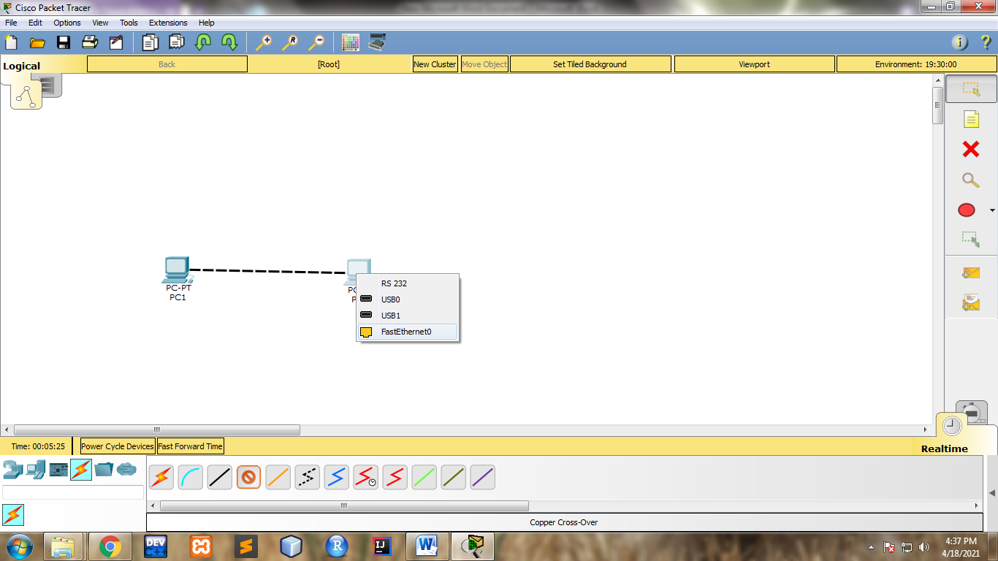

**Step 7:-Now Left click on first pc and select desktop tab and select IP configuration tab. select static IP and put a desired unique IP address of your choice in correct format. Close the tab.**

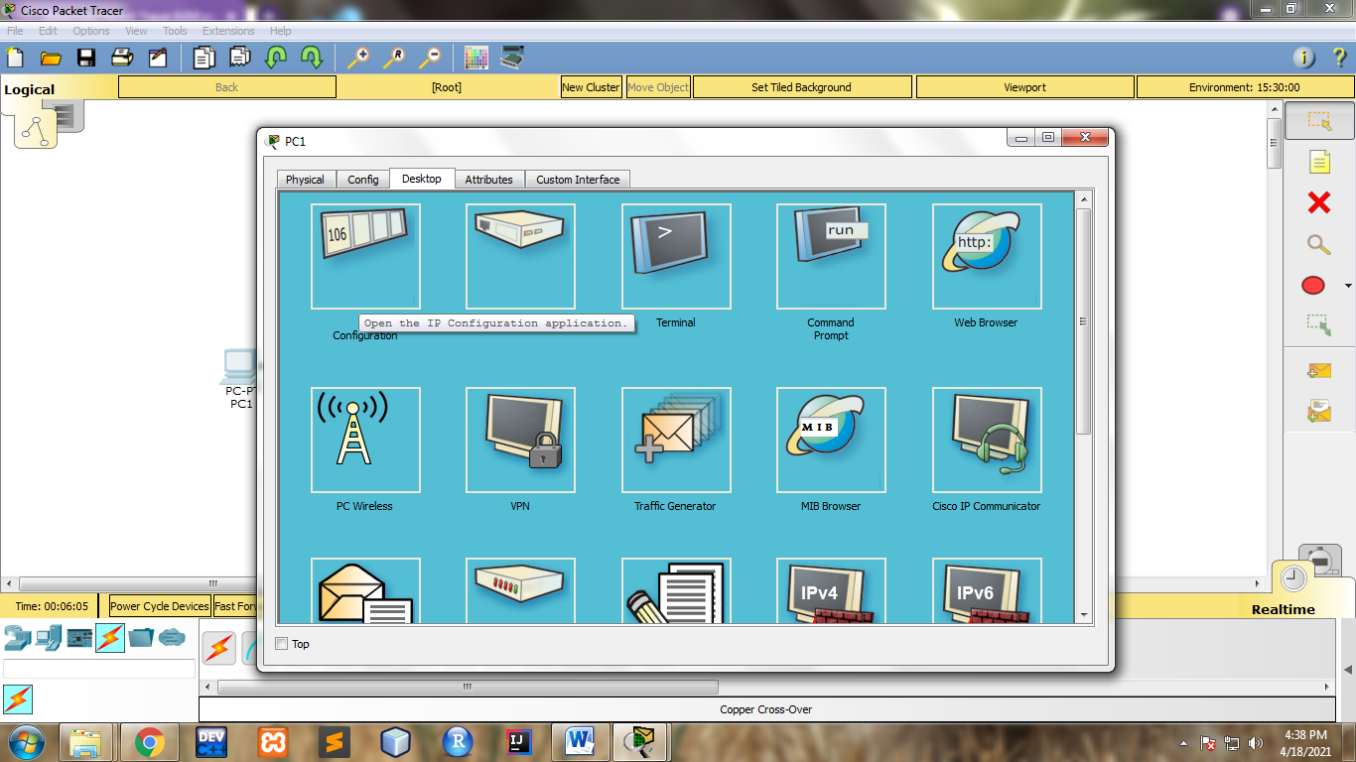

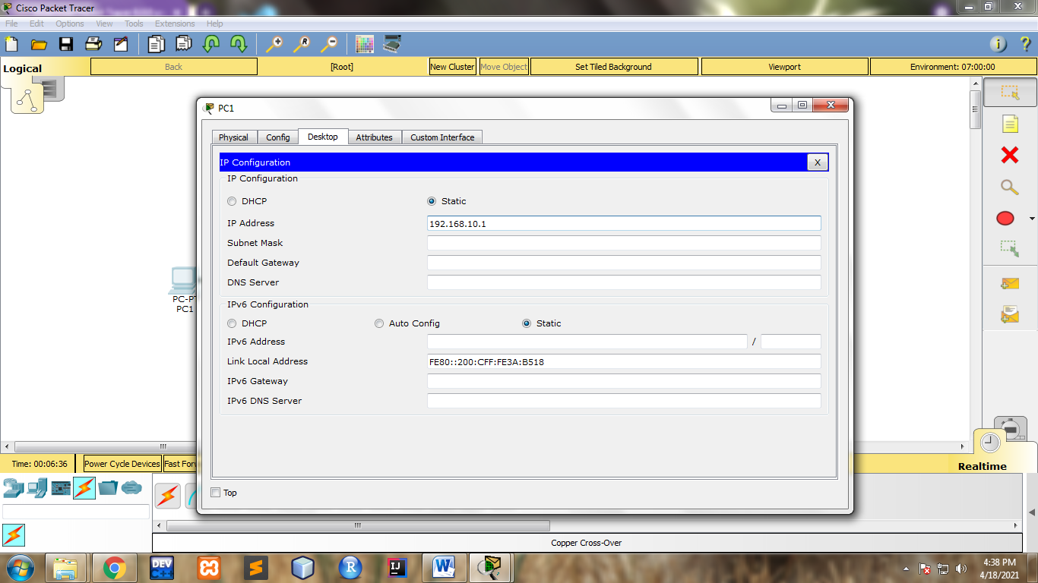

**Step 8:-Again Left click on second pc and select desktop tab and select IP configuration tab. select static IP and put a desired unique IP address of your choice in correct format. Close the tab.**

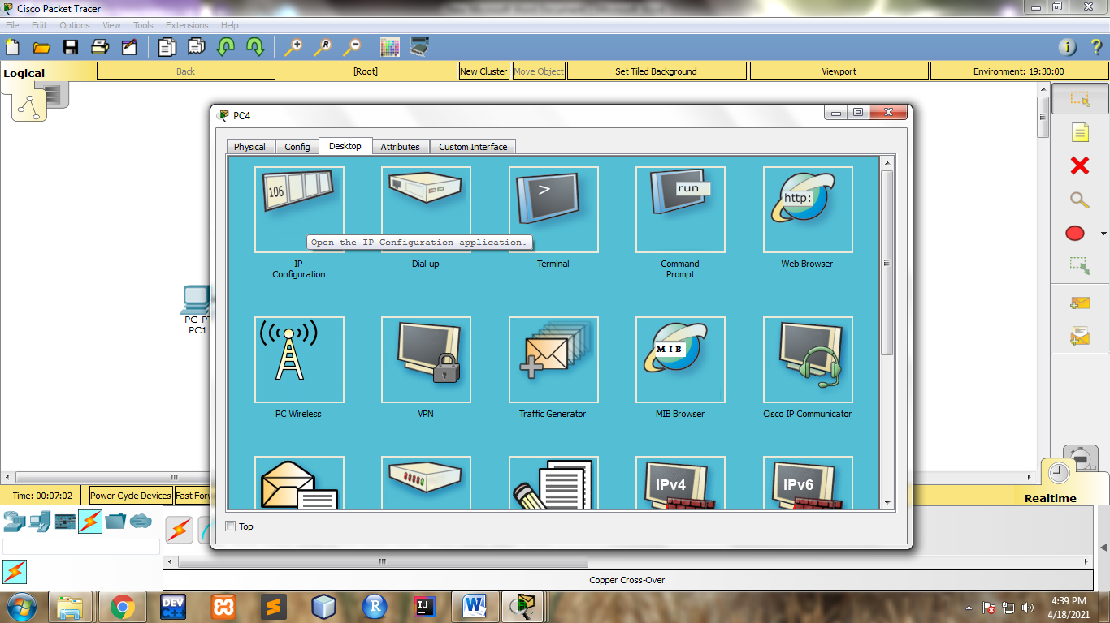

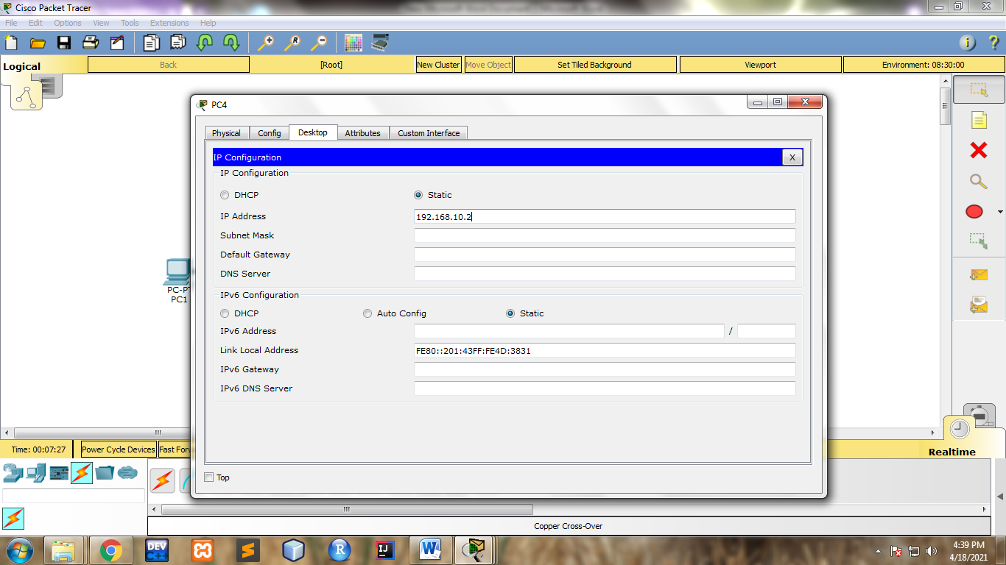

**Step 9:- Again Left click on first pc and select desktop tab and select command prompt tab.**

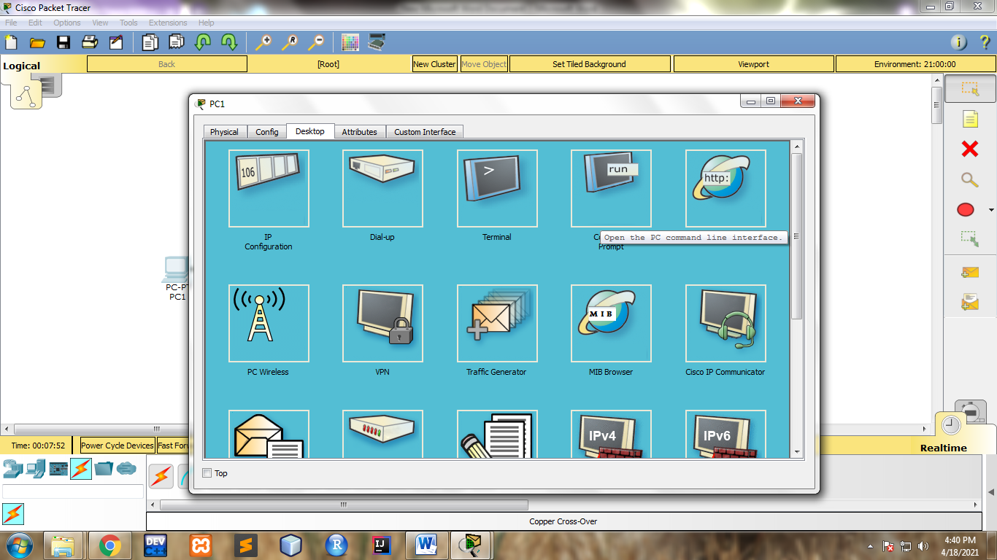

**Step 10:-Use the ping command with ip address of second pc to check whether second pc is connected or not**

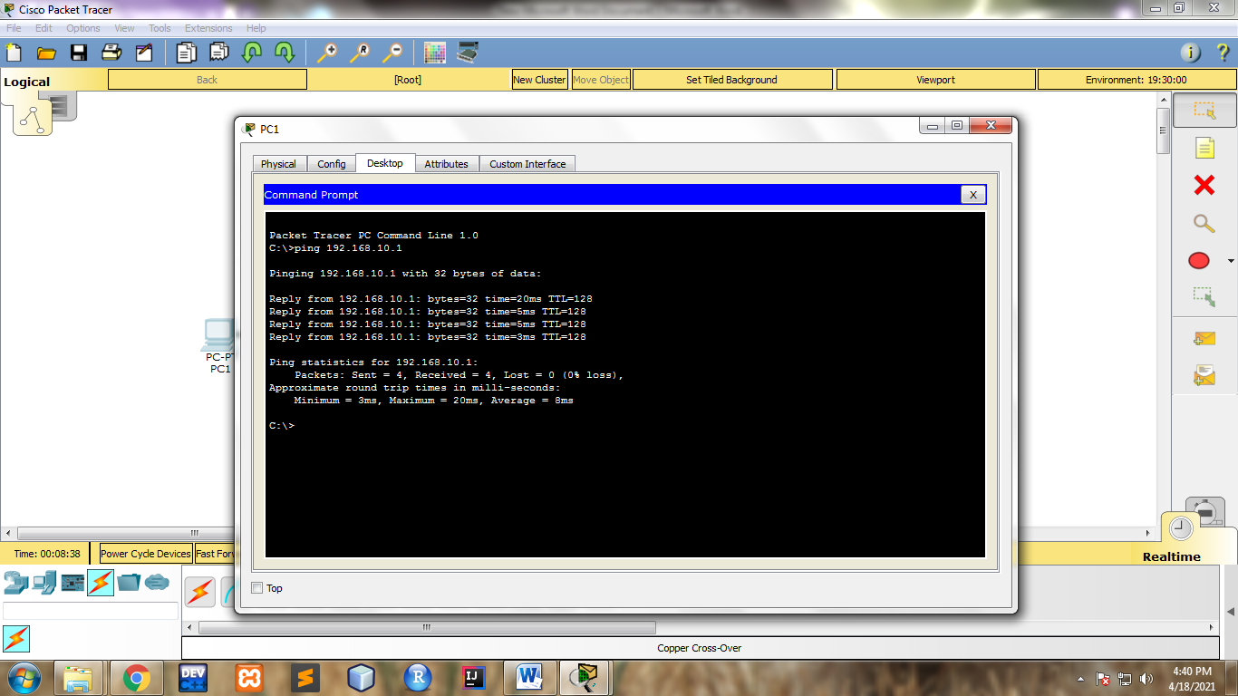

**Step 11:- Again Left click on second pc and select desktop tab and select command prompt tab.**

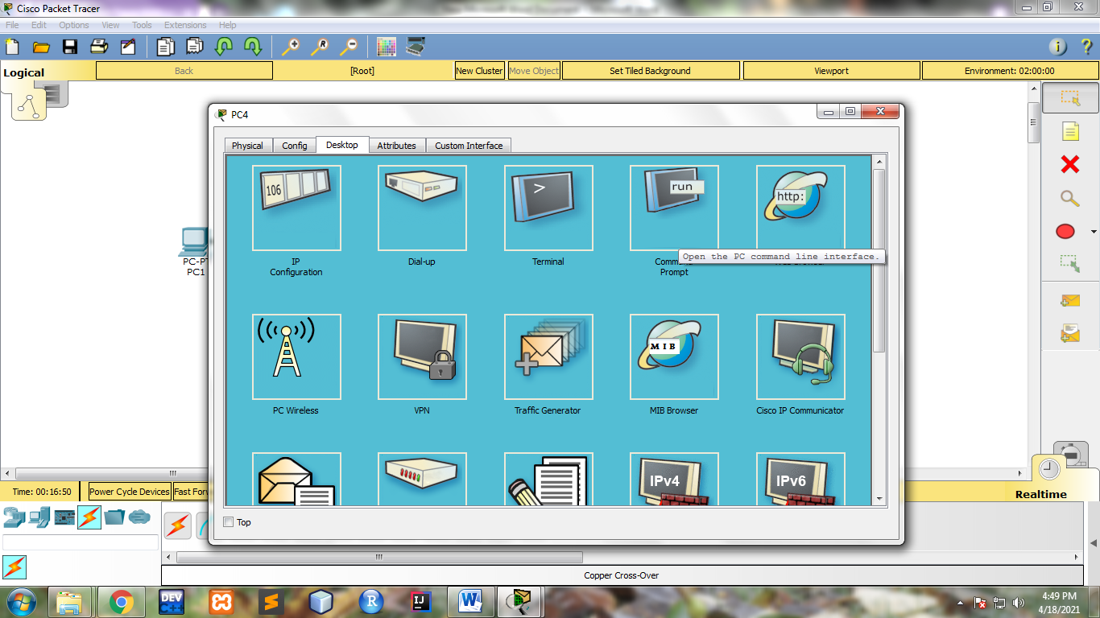

**Step 12:-Use the ping command with ip address of first pc again to check whether first pc is connected or not**

